Light Mixing

Subject: Optics  Related Subjects:Spectroscopy | Grade Level(s): 4 & 5  Length of Lesson: | Type: Inquiry / Design / Project  Keywords:Prism, Wavelength, Frequency, Color

Lesson Overview
Students will create describe what they see when light is put through a prism. Seeing this, students will later make up their own ideas on how to mix light to achieve specified colors by using filtered color paper. Moreover, students will create a true mirror to explore the way light works.

Lesson Focus
Students will explore the process of mixing colors, as well as develop an intuitive sense of how light can be manipulated to create different colors.

Lesson Objective(s) | The student will learn about light diffraction, color, and intensity.

Lesson Timing

Time [min] | Description
5 | Introduce the Lesson  - End Goal  - Primer Questions  - Key Vocab Words
1 | Role Models in STEM
Engineering Method
5 | Real World Example
5 | Hypothesis & Prediction
5 | Brainstorm & Design
20 | Build & Create
10 | Test & Record
5 | Assess & Evaluate
5 | How to improve?
10 | Lesson Cleanup

Materials | - 6 Flashlights of different types (LEDs, fluorescent, incandescent, etc)  - 6 Diffraction gratings  - White cardboard sheets (for creating slits)  - 6 Convex lenses  - 6 Concave lenses  - Assortment of light filter paper  - 6 Prisms  - 40 large binder paper clips
Instructor Prep | - Step 1
Related Resources | - List related lessons/ppts etc available from USC or outside, trusted orgs

Lesson Plan

Introduction
- What is light?
  - Light is a form of electromagnetic radiation and is also a particle (photons).
- What are things that use light to work?
  - Lightbulbs
  - Solar panels
  - Plants

Procedure

- Place flashlight on the table and cut slit on cardboard
- Allow students to turn on flashlight and allow them to explore for a minute or so
- Ask students what would happen to prism if placed in front of light beam
- Allow students to make observations. Students should record their observations down in a notebook so that they can potentially be used for later reference
- Place light filter papers (one of each color) on tables and allow students to explore with the paper for two minutes
- Ask how many combinations of colors they can make with the given filter papers.
- Have students record observations so that questions can be asked
- Allow 5 minutes or so of extra time for students to see if they can have their own questions answered through extra experimentation

Wrap-up
The purpose of the survey is to let us know your opinions about today’s project. Remember there are no right or wrong answers.

 |  | Strongly Disagree | Disagree | Undecided | Agree | Strongly Agree
1 | The project increased my interest in science
2 | After this project, I am more confident in doing science

3. What does a physicist do?

4. How do different colors mix?

5. How does intensity of light affect the resultant color?

Lesson Background for Teachers

Suggested Real-World STEM Connections

Real World Example
- What are important things that use light to operate?
- How have engineers/scientists used this principle to invent new things?

Hypothesis & Prediction
- Is white light a primary color of light?
- Will light intensity make a difference in the output color of light?

Brainstorm & Design
- How can we setup the light bulbs to create a specific color?
- How can we create a true mirror knowing the how reflection works?

Build & Create
- Students can setup their experiments using binder clips, cardboard sheets, flashlights, and filter paper to create combinations of different colors

Test & Record
- Students will setup their experiment and then test the setup by passing light through the filter paper and attempting to create each of the secondary colors (yellow, purple, cyan)
- Students will record these observations and attempt to create other combinations of light to apply knowledge acquired through first step of experiment

Assess & Evaluate
- The degree to which their apparatus can create a desired color of light with simply telling them a color to make (excluding unsaturated colors).

How to Improve?
- What different items could be used to improve the experiment?
- Inclusion of other light sources (such as black lights) to further extend the idea that light is in many different forms that we simply do not see.

Role Model in STEM

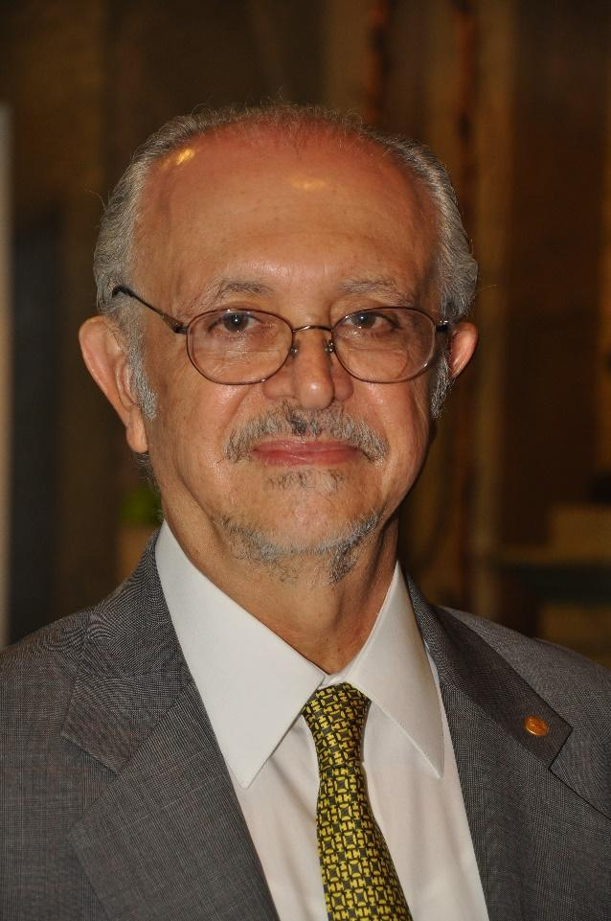
Name: Mario J Molina
Years: 1943-Present
Quick Facts
- Born in Mexico City, Mexico and is the first Mexican-born citizen to receive Nobel Prize
- Won Nobel Prize for his work on chlorofluorocarbons (CFCs) and warning against their use
- Discovered Antarctic ozone hole
- Molina is a member of the National Academy of Sciences and the Institute of Medicine.

Lesson Variations and Options
Include descriptions of alternative methods or ways to present things.

Explanation
Light mixing is an everyday phenomenon that is many times taken for granted. However it makes up the majority of our lives, from the simple lightbulb, to the complicated OLED displays in our phones and computers, to the measuring of atomic mass.

Pure white light isn’t truly a color. In fact it is a mixture of a ton of separate spectra of color bands, consisting of blue, red, green, magenta, indigo, etc. While these colors may appear to share the same basic properties of paints or pigments, they do not mix in the same fashion. Light undergoes a process called additive mixing, whereby light adds up closer to white, while pigments and paint go through subtractive mixing, where each color adds up closer to black.

Key Concepts and Vocabulary
- Electromagnetic Radiation
  - A kind of radiation including visible light, radio waves, gamma rays, and X-rays, in which electric and magnetic fields vary simultaneously
- Color
  - A specific wavelength or frequency of light that our brains then perceive as a specific color
- Frequency
  - The number of times a wave of light completes an entire cycle, usually per second (hz).
- Wavelength
  - The length between each successive cycle of a wave
- Prism
  - A tool used to split light into each of its color parts that works through refraction of different wavelengths of light
  - A color
- Visible Spectrum
  - The range of light that we can see
- Primary Colors
  - Colors that form the basis of color mixing

Safety Notes
- Safety instruction

